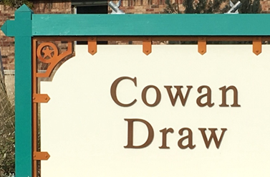
N48 Newsletter
May 2023

Monday, May 29, 5 pm
Memorial Day Picnic (and N48 donation time)!
Join your N48 friends for a picnic at the Cowan Creek Pavilion on Monday, May 29th at 5pm. Let us never forget those who paid the ultimate price so we could have the freedom to enjoy times like this in peace. Plan to attend the largest block party of the year, sponsored by your block captains. We will be providing hot dogs, buns, condiments and cake for dessert. Please bring a side dish to share and your beverage of choice.
Each year at our Memorial Day picnic we put out a basket so you can contribute to our neighborhood. Your donations fund our neighborhood decorations at the entrances, flags for the mailboxes, paper products for our parties, and Social Committee events that require decorations, etc. We are thankful for your support of our N48 efforts with a once-yearly donation to keep N48 rocking. Suggested donation is $10/person.
Please register on the website by Friday, May 26th so we can buy the right quantity of hot dogs, cake, etc. Questions? Contact Jim Nobert, 817-676-6078.
Friday, May 12, 8am – Noon
NRO Anti-Fraud Town Hall Can you guess the number one crime in Sun City? FRAUD! We all think we are too smart to be a victim. However, the bad guys are very savvy. To help us avoid fraud, NRO's Anti-Fraud group is putting on a Town Hall meeting May 12th from 8am to noon in the Retreat Lone Star Room. Please plan to attend, as it promises to be very informative.

Tuesday, May 16, 4-6pm
Ladies’ Happy Hour - Come and join the Ladies of N48 for a Happy Hour from 4:00 - 6:00 pm on Tuesday, May 16th, at the home of Denise Rowland, 217 Coffee Mill Creek Road. Please bring a beverage of your choice and an appetizer to share. No registration needed. Wear your name-tag, as it is helpful for both new and long-time neighbors!

Thursday, May 18, 4-6pm
Men’s Happy Hour – Come join the Men of N48 for a Happy Hour on Thursday, May 18th, from 4:00 to 6:00 pm at the home of Bob Jones, 103 Coffee Mill Creek Road. Please bring a beverage of your choice and an appetizer to share. No registration needed, but please wear your nametag!

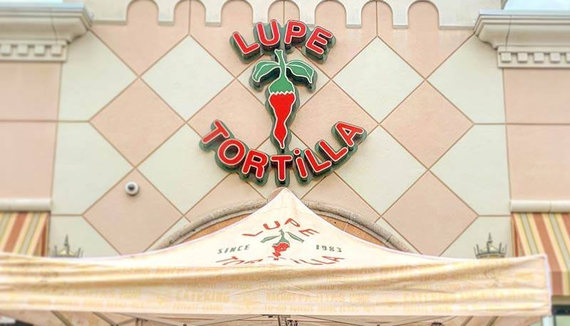
Tuesday, May 23, 11:30am May Men's Lunch will be held at Lupe Tortilla, 240 Bass Pro Drive in Round Rock (by the Outlet Center). The scheduled date is Tuesday, May 23rd at 11:30 am. If you plan to attend and enjoy lunch with neighborhood friends, please register by Sunday, May 21st on the website. Any questions, give Judy Parsley a call - 512-214-9687. Lupe Tortilla website - https://tex-mex.com/austin-roundrock/

Wednesday, May 24, 11:30am
The May Ladies' Lunch will be held at Lupe Tortilla, 240 Bass Pro Drive in Round Rock (by the Outlet Center). The scheduled date is Wednesday, May 24th at 11:30 am. If you plan to attend, please register by Monday, May 22nd on the website. Any questions, give Judy Parsley a call - 512-214-9687. Lupe Tortilla website - https://tex-mex.com/austin-roundrock/

Upcoming 2023 Themed Event Dates
Date | Event Name | Location
Sun, July 23 | Christmas in July | Retreat – Lone Star Room
Sat, Oct 7 | 70’s Disco Night | The Oaks (formerly Legacy Restaurant)

Mark Your Calendar! Sign up Now for this Saturday, June 10 Event
Come join your neighbors for a casual round of golf at Georgetown’s newest family-owned mini-golf course!
Cen-Tex Mini Golf
Event Date: Saturday, June 10
Event Time: 11 am tee-off
Event Location: Cen-Tex Mini-Golf, 5020 Airport Road, GT
Event Cost: $11 per person for 18 holes of golf; includes access to their outdoor party space after we finish playing. Feel free to bring your lunch and chair, and relax in the shade of the trees in their party space after game time.
Please remember to register on our website and pay either by cash, or a check made out to Neighborhood 48 (not N48 please!) – by June 3rd. There will be a box in Nancy Chessman’s front entryway (225 Coffee Mill) in which you can deposit your payment. Contact is Dianna Franzen, ddfranz@ameritech.net

Hope to see y’all on the course!

Save the Date!
Don't miss out on N48's "Christmas in July" scheduled for Sunday, July 23, from 4:30-9:00 p.m. at the Retreat Lone Star Room (1220 Cattleman Drive). This is a themed event with lots of holiday colors, festivity, games, music, and, yes, holiday foods. Please find more information on our website.

2023 Cul-de-Sac Parties
Date | Block | Time | Location
January 22 | Judy Hofer (#7) | 6:00 pm | Georgetown/Florence Room
March 12 | Char Wehner (#5) | 5:00 pm | CMC Cul-de-Sac
April 16 | Boyd Chessman (#4) | 5:00 pm | CMC Cul-de-Sac
June 11 | Debbie James (#2) | 6:00 pm | Georgetown/Florence Room
July 16 | Cheryl McDonald (#3 | 6:00 pm | Georgetown/Florence Room
August 13 | Jim Burrell (#1) | 6:00 pm | Georgetown/Florence Room
SATURDAY  September 16 | Belen Nobert (#8) | 5:00 pm | Cowan Pavilion
October 15 | Tom Newton (#9) | 5:00 pm | SJC Cul-de-Sac
November 12 | Bruce Bateman (#6) | 5:00 pm | CCC Cul-de-Sac

